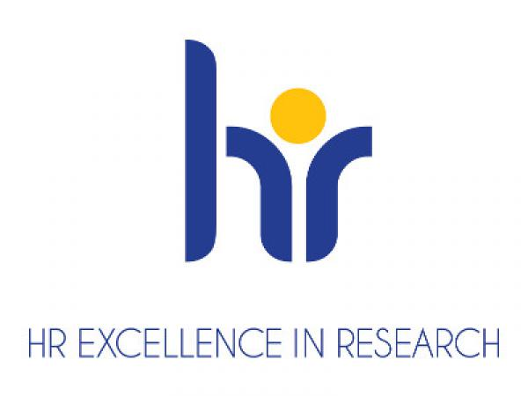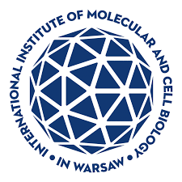
Postdoctoral Researcher position (role in the project Junior Postdoctoral Researcher)

Recruitment for the project “RNA and Cell Biology Platform for Research and Innovation in Medicine (RACE-PRIME)” (grant agreement no. FENG.02.01-IP.05-T003/23) implemented within the framework of the International Research Agendas funded by the European Funds for Smart Economy programme, for the position of Junior Postdoctoral Researcher to carry out research work in the cell biology area under the direction of Prof. Marta Miączyńska, head of the Laboratory of Cell Biology
at the International Institute of Molecular and Cell Biology in Warsaw (IIMCB), in collaboration
with Dr Katarzyna Mleczko-Sanecka (Laboratory of Iron Homeostasis).

The main objective of RACE-PRIME is to transform the IIMCB into a world-class center of excellence in RNA and cell biology. The premise of RACE-PRIME is the translational use of the results of basic research, e.g. to develop the premise of new therapies, diagnostic methods, discover new therapeutic objectives or to identify molecules with desirable properties so that they can be developed into medications.

Description of the project area: We are seeking a researcher to investigate iron homeostasis in rare human diseases, focusing on how cellular iron levels impact metabolic functions and contribute to disease pathologies. Additionally, the research will involve manipulating iron levels to alleviate disease symptoms, particularly those related to proteostasis defects and neurological conditions. The goal is to uncover novel therapeutic targets by understanding the interplay between iron homeostasis, ferroptosis, and protein aggregation using advanced cellular and animal models.

Job description: the Postdoctoral Researcher will be responsible for applying a variety of assays, in cellular models and animal models to assess aberrations of iron homeostasis and the influence of manipulation of iron levels on pathological phenotypes (eg, protein aggregation or cell viability).

Requirements for the candidate:
- Possession of Ph.D.in biological sciences or a related field obtained for no more than 5 years; however, the 5-year period is calculated from the year of obtaining the Ph.D. or candidate plans to defend his/her dissertation prior to the start of employment (planned date is date or later).
- Has solid knowledge and documented laboratory experience in cellular and molecular biology.
- Has expertise or shows strong interests in iron biology, is motivated for experimental work, shows passion for science.
- Shows readiness to learn new skills and take challenges, has initiative and can work independently and think analytically.
- Has excellent interpersonal skills, and the ability to work within a team.
- Has the ability to draft (in English) scientific papers for academic journals.
- Has the ability to communicate (in English) complex information clearly, orally and in writing.
- Has good presentation skills (ideally having presented during at least one international conference).
- Publications in international peer-reviewed journals.

Selection criteria:
- Technical competence, experience and fit of the expertise to the position.
- Scientific achievements - publications, awards, grants, etc.
- Soft skills – command of English language, motivation letter, communication skills, teamwork, likelihood to fit to the team, compatibility of plans for individual development with the goals of the project.
Candidates will be selected in an open competition, according to the procedure complying
with the rules of the European Charter for Researchers and the Code of Conduct for the Recruitment of Researchers as a part of HR Excellence in Research strategy https://shorturl.at/fjot2
We offer:
- Full employment contract initially for 6 months with further extension
- Competitive salary from 9 700 pln gross/month to 10 280 pln gross/month (depending on experience).
- Benefits including reduced-rate for an individual private medical care package and membership in the MultiSport programme.
- Full technical, administrative and organizational support from professional English-speaking personnel.
- Participation in courses, scientific trainings and support from peers.

Deadline for applications is 31.10.2024. Job starting date is 01.12.2024 or later.

How to apply:
- Apply via : (link)
- Your application must be submitted in English and should contain a CV including a full list
of publications, a motivation letter with description of your key achievements, and contact details (e-mail and telephone number) of least two potential referees, including one
of your direct supervisor.
- Please include the following statement in your CV: “I hereby agree to the processing
of my personal data, included in the application documents by the International Institute
of Molecular and Cell Biology in Warsaw, 4 Księcia Trojdena Street, 02-109 Warsaw,
for the purpose of carrying out the current recruitment process.” Your personal data will
be processed for the purpose of the recruitment procedure by the International Institute
of Molecular and Cell Biology in Warsaw. Full information is available under the link https://bit.ly/3UFWpY2
- Procedure for reporting irregularities, taking follow-up actions, and protecting whistleblowers: https://shorturl.at/u2mww

The competition may be extended until a suitable candidate who fulfils all requirements is found.

