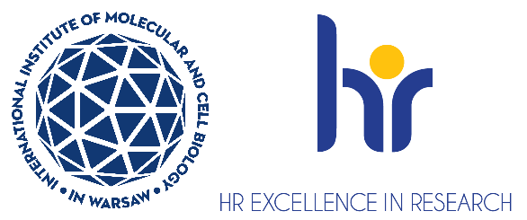

Research Specialist positions in the Laboratory of Protein Structure

Laboratory of Protein Structure https://shorturl.at/iZTMe in the International Institute of Molecular and Cell Biology (IIMCB), Warsaw, headed by Prof. Marcin Nowotny, seeks motivated Research Specialist to join a project that aims at elucidating the mechanisms of plastid genome packaging.
You will work on the project funded by NAWA BPN/NSF/2023/1/00011 entitled: “IMPRESS-U DCL: Supplement: Structure and function of plastid nucleoid.” as part of the initiative „International Multilateral Partnerships for Resilient Education and Science System in Ukraine IMPRESS-U”.

As a research specialist you will be responsible for preparation of expression constructs, protein expression in bacterial and eukaryotic systems, protein purification and characterization
of protein-nucleic acid interactions.
Requirements:
- Holds BSc or MSc degree in biology, pharmacology, chemistry, biochemistry or related discipline
- Has previous lab experience, preferably in protein biochemistry
- Has knowledge in scientific data analysis
- Has excellent interpersonal skills, initiative and ability to work independently and in a high-performance team
Selection criteria:
- Education, technical competencies, experience, and alignment of specialized knowledge with the requirements of the position.
- Proficiency in spoken and written English.
- Soft skills - motivation letter, communication skills, ability for effective teamwork, likelihood to fit to the group, compatibility of plans for individual development with the goals of the group.
We offer:
- Full employment contract initially for 6 months, with the possibility of extension up to the end of the project.
- Gross monthly salary approx. 6600 pln/month (The final monthly gross salary will be calculated individually during the employment process, taking into account the length of service. Additional bonuses such as the 13th salary, after working for the Institute for six months in a given calendar year)
- A friendly working atmosphere in an international environment
- Interesting scientific projects
- Position with 100% focus on research (no teaching obligations)
- Benefits including reduced-rate for an individual medical care package and membership
in MultiSport programme
- Full technical, administrative and organizational support from professional English-speaking personnel
- Opportunities for professional development - participation in courses, foreign conferences, funding for postgraduate studies, assistance in submitting your own grants

The deadline for applications is December 1st, 2025. Job starting date is January 1st, 2026, or as soon as possible after this date.
How to apply:
- Apply via the recruitment system: erecruiter
- Your application must be submitted in English and should contain one file including:
  - CV (including list of publications and list of skills)
  - motivation letter (including description of your key achievements, max one page)
  - contact information to 2 people who can evaluate you (such as your thesis supervisor, academic advisor)
- Please include the following statement in your CV:
“I hereby agree to the processing of my personal data, included in the application documents by the International Institute of Molecular and Cell Biology in Warsaw, 4 Księcia Trojdena Street, 02-109 Warsaw, for the purpose of carrying out the current recruitment process.” Your personal data will be processed for the purpose of the recruitment procedure by the International Institute of Molecular and Cell Biology in Warsaw. Full information is available https://bit.ly/3ObTUdJ
Candidates will be selected in an open competition, according to the procedure complying with the rules of the European Charter for Researchers and the Code of Conduct for the Recruitment of Researchers as a part of HR Excellence in Research strategy https://career.iimcb.gov.pl/hr-excellence-in-research/
Procedure for reporting irregularities, taking follow-up actions, and protecting whistleblowers: https://shorturl.at/u2mww.

The competition may be extended until a suitable candidate who fulfils all requirements is found.

