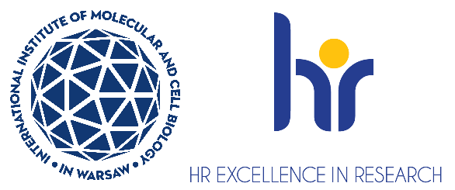

Postdoctoral Researcher positions in Laboratory of Protein Structure
Laboratory of Protein Structure ( https://shorturl.at/iZTMe ) at the International Institute of Molecular and Cell Biology (IIMCB), Warsaw, headed by Prof. Marcin Nowotny is looking
for Postdoctoral Researcher to join the project entitled “Structural and mechanistic studies
of replication of (+)ssRNA viruses”, which is carried out as the OPUS2021/41/B/NZ1/03620 grant
of the Polish National Science Centre. The project aims at the structural and mechanistic characterization of RNA replication in RNA viruses using structural biology (crystallography and
cryo-electron microscopy) and protein biochemistry approaches.

The ideal candidate should be able to pursue challenging tasks and achieve objectives and collaborate with other researchers. Candidates will be selected in an open competition, according to the procedure complying with the rules of the European Charter for Researchers and the Code of Conduct for the Recruitment of Researchers as a part of HR Excellence in Research strategy https://shorturl.at/r8z8b

As a Postdoctoral Researcher: You will be responsible for structural studies of viral replicases.

Requirements:
- Holds a doctoral degree in biology, biotechnology, or biochemistry.
- Fulfills the formal criteria for the competition https://bit.ly/32EvANI in particular section 2.1.1
- Has experience in protein biochemistry/purification (particularly for nucleic acid enzymes), crystallography and/or cryo-EM
- Has strong written and oral communication skills in English
- Has good presentation skills (ideally having presented during at least one international conference).
- Enjoys working in a highly collaborative and interdisciplinary environment.
- Has published at least one publication as the first author in an international peer-reviewed journal.

SELECTION CRITERIA:
Applications will be evaluated based on the following criteria:
- Education and formal qualifications.
- Technical expertise and relevance of experience to the project.
- Scientific achievements (e.g., publications, awards, grants, international collaborations).
- Proficiency in English (written and spoken).
- Soft skills, including:
  - Clarity and impact of motivation letter.
  - Communication and teamwork abilities.
  - Organizational and time-management skills.
  - Compatibility with the research group’s goals and vision.

We offer:
- Full employment contract initially for 6 months with the possibility of extension
- Gross monthly remuneration: 9700 PLN/month gross.
- Additional bonuses such as the 13th salary after working for the Institute for six months in a given calendar year, or Christmas bonus may supplement this salary.
- Position with 100% focus on research (no teaching obligations)
- Benefits including reduced-rate for an individual medical care package and membership
in MultiSport programme
- Full technical, administrative and organizational support from professional English-speaking personnel
- Participation in courses, scientific training, support from peers, and academic mentoring

Deadline for applications is December 31st, 2025. Job starting date is January 15th, 2026 or as soon
as possible after this date.

How to apply:
- Apply now via recruitment system : erecruiter
- Your application must be submitted in English and should contain a CV, a motivation letter, a description of your key achievements, and contact details at least two potential referees, including one of your supervisors
- Please include the following statement in your CV: “I hereby agree to the processing
of my personal data, included in the application documents by the International Institute of Molecular and Cell Biology in Warsaw, 4 Księcia Trojdena Street, 02-109 Warsaw, for the purpose of carrying
out the current recruitment process.” Your personal data will be processed for the purpose of the recruitment procedure by the International Institute of Molecular and Cell Biology in Warsaw.
Full information is available under the link https://bit.ly/3UFWpY2
- Procedure for reporting irregularities, taking follow-up actions, and protecting whistleblowers: https://shorturl.at/u2mww.

The competition may be extended until a suitable candidate who fulfils all requirements
is found.

