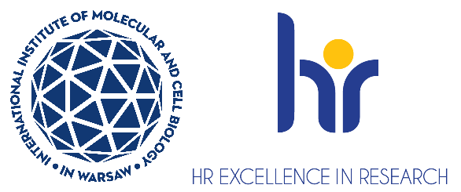

Postdoctoral Researcher position in the Laboratory of Protein Structure
Laboratory of Protein Structure https://shorturl.at/iZTMe in the International Institute of Molecular and Cell Biology (IIMCB), Warsaw, headed by Prof. Marcin Nowotny, seeks a motivated Postdoctoral Researcher to join a project that aims at elucidation of the mechanisms of plastid genome packaging.
You will work on the project funded by NAWA BPN/NSF/2023/1/00011 entitled: “IMPRESS-U DCL: Supplement: Structure and function of plastid nucleoid.” as part of the initiative „International Multilateral Partnerships for Resilient Education and Science System in Ukraine IMPRESS-U”.
The deadline for applications is December 1st, 2025, 2025. Job starting date is January 1st, 2026 or as soon as possible after this date.
As a postdoctoral researcher you will be responsible for establishing the currently unknown mechanisms of DNA packaging in plastids. The tasks will involve purification of proteins involved in this process and their biochemical and structural studies using cryo-EM and protein crystallography.
Requirements:
- Hold a PhD degree in Biology, Biotechnology, Medicine or equivalent field. Candidates with degrees in other fields including Engineering, Computer science, Physics will also be considered if they have relevant experience
- Has experience in protein biochemistry/purification (particularly for nucleic acid enzymes), knowledge of crystallography and/or cryo-EM will be a plus
- Has strong written and oral communication skills in English
- Has good presentation skills (ideally having presented during at least one international conference).
- Enjoys working in a highly collaborative and interdisciplinary environment.
- Has published at least one publication as the first author in an international peer-reviewed journal.
- High motivation and proactive and collaborative attitude

Selection criteria:
- Education, technical competencies, experience, and alignment of specialized knowledge with the requirements of the position.
- Scientific achievements - publications, awards, grants, national and international training, etc.
- Proficiency in spoken and written English.
- Soft skills - motivation letter, communication skills, ability for effective teamwork, likelihood to fit to the group, compatibility of plans for individual development with the goals of the group.

Candidates will be selected in an open competition, according to the procedure complying with the rules of the European Charter for Researchers and the Code of Conduct for the Recruitment of Researchers as a part of HR Excellence in Research strategy https://shorturl.at/fjot2
We offer:
- Full employment contract initially for 6 months, with the possibility of extension up to 24 months
- Gross monthly salary approx. 9700 PLN/month - the final monthly gross salary will be calculated individually during the employment process, taking into account the length of service. Additional bonuses such as the 13th salary (after working for the Institute for six months in a given calendar year)
- A friendly working atmosphere in an international environment
- Interesting scientific projects
- Position with 100% focus on research (no teaching obligations)
- Benefits including reduced-rate for an individual medical care package and membership
in MultiSport programme
- Full technical, administrative and organizational support from professional English-speaking personnel
- Opportunities for professional development - participation in courses, foreign conferences, funding for postgraduate studies, assistance in submitting your own grants
How to apply:
- Apply through the recruitment system: erecruiter
- Your application must be submitted in English and should contain one file including:
  - CV (including list of publications and list of skills)
  - motivation letter (including description of your key achievements, max one page)
  - contact information to 2-3 people who can evaluate you (such as your thesis supervisor, academic advisor)
- Please include the following statement in your CV:

“I hereby agree to the processing of my personal data, included in the application documents by the International Institute of Molecular and Cell Biology in Warsaw, 4 Księcia Trojdena Street, 02-109 Warsaw, for the purpose of carrying out the current recruitment process.”
Your personal data will be processed for the purpose of the recruitment procedure by the International Institute of Molecular and Cell Biology in Warsaw. Full information is available https://bit.ly/3ObTUdJ
Procedure for reporting irregularities, taking follow-up actions, and protecting whistleblowers: https://shorturl.at/u2mww
Candidates will be selected in an open competition, according to the procedure complying with the rules of the European Charter for Researchers and the Code of Conduct for the Recruitment of Researchers as a part of HR Excellence in Research strategy https://shorturl.at/r8z8b

