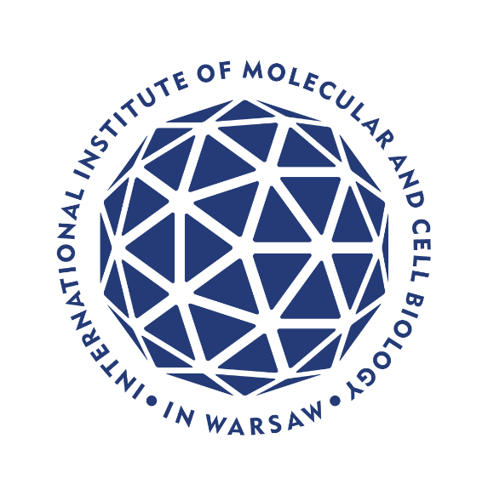
JUNIOR GROUP LEADER in COMPUTATIONAL BIOLOGY
Professor position

The International Institute of Molecular and Cell Biology in Warsaw (IIMCB), Poland
invites applications for Junior Group Leader in Computational Biology

Opportunity Overview

The IIMCB, invites applications for a Junior Group Leader in Computational Biology. This is a professor-level position with an initial five-year appointment on a rolling tenure-track, offering a full-time salary, comprehensive benefits, and a competitive start-up package. We seek a talented, dynamic, and motivated early-career computational biologist to establish their first independent research group within our vibrant scientific environment. The ideal candidate will leverage computational approaches to drive new fundamental discoveries in RNA and cell biology. This may include, but is not limited to, the development of new methods for multiomics or image analysis, approaches using artificial intelligence (AI) and machine learning (ML), or advanced numerical simulations. Your expertise will enrich IIMCB’s research and foster collaborations by using computational insights to unravel molecular mechanisms from single molecules to complex cellular systems, in line with IIMCB’s mission to address fundamental questions in biology and respond to health-related societal challenges.

Major Research Initiatives and Collaborations

Successful candidates will join the ambitious initiatives funded by the prominent EU projects focused on:
- institutional development - RACE: “RNA and Cell Biology - from Fundamental Research to Therapies” (Teaming for Excellence under Horizon Europe)
- scientific development - RACE-PRIME: “RNA and Cell Biology Platform for Research and Innovation in Medicine” (International Research Agendas program co-financed by the EU under the European Funds for Smart Economy 2021-2027)

Through RACE and RACE-PRIME, and in partnership with The University of Edinburgh and the Flanders Institute for Biotechnology (VIB), IIMCB is establishing itself as a highly recognized international research center where excellent fundamental science is complemented by professional technology transfer to biomedical applications. The Institute’s state-of-the-art facilities – and the prospect of a larger, new research building – provide new group leaders with exceptional opportunities for scientific and personal development.

Cutting-Edge Infrastructure

Research at IIMCB is supported by advanced core facilities (IN-MOL-CELL Infrastructure) developed under the European Recovery and Resilience Plan “Research Infrastructure for Molecules and Cells”. All group leaders have access to state-of-the-art equipment and expert services. For computational biology, IIMCB offers dedicated high-performance computing resources designed for data-intensive and AI-driven research:
- High-Performance Computing (HPC) Cluster: ~4000 CPU cores with 5 TB RAM, suitable for high I/O and large memory workloads.
- Mass Data Storage: 2.5 PB of networked storage, plus an additional 150 TB high-speed SSD storage for fast data access.
- GPU Supercomputing: A GPU server with 8 × NVIDIA RTX A5000 GPUs and 1 TB RAM for machine learning and simulation tasks.
- External HPC Access: Professional support to obtain access to national and international supercomputing centres (e.g. the PLGrid), extending your computational capabilities.

Vibrant International Environment

IIMCB hosts a vibrant, multinational scientific community and is actively embedded in international networks, as exemplified by the IIMCB’s International Advisory Board and membership in the EU-LIFE, an alliance of Europe’s leading life science research institutes. Our faculty of sixteen group leaders includes internationally recognized scientists – including EMBO Members and ERC grant laureates – who foster a culture of high-impact research. As part of the Warsaw-4-PhD doctoral school consortium, IIMCB group leaders can supervise PhD students across disciplines (physics, chemistry, biology, medical sciences) without formal teaching duties, allowing you to focus fully on research and mentorship. Within this supportive environment you will develop your own research program, build your team, and establish collaborations both within IIMCB and with external partners worldwide. English is the working language of the institute, and international newcomers are welcome – fluency in Polish is not required to live and work in Warsaw. Importantly, Poland is recognized as safe, friendly and prosperous country https://travelmaps.state.gov/TSGMap/

What We Offer

Joining IIMCB as a Junior Group Leader comes with a comprehensive support package to ensure your research success and career development:

- Faculty Appointment: Professor-level position with an initial 5-year appointment, with rolling tenure-track extension subject to positive periodic evaluations by the IIMCB’s International Advisory Board.
- Salary & Benefits: Full-time employment with a competitive salary and extensive social benefits (health insurance, pension, etc.).
- Start-Up & Core Funding: A generous start-up funding package to establish your lab, followed by sustained core funding to support your research after the start-up period.
- Facilities Access: Full access to IIMCB’s state-of-the-art laboratories and equipment, including all IN-MOL-CELL core facilities and services.
- PhD Programme Engagement: Opportunity to co-supervise doctoral students through the Warsaw-4-PhD programme, with no teaching obligations.
- Institutional Voice: Participation in IIMCB’s decision-making as a member of the Laboratory Leaders’ Council, allowing you to contribute to institute-wide scientific strategy and operations.
- Grant Application Support: Extensive support from an experienced team to strengthen your applications for national and international grants – including identifying funding opportunities, budget preparation, data management plans, ethical compliance, and ensuring all submission requirements are met.
- Administrative Support: Comprehensive organizational and administrative assistance from professional, English-speaking staff (including IT support), reducing bureaucratic burdens on your research.
- Relocation Assistance: Personalised help for you (and your partner/family) in relocating to Poland – support with visa processes, obtaining residency permits, and finding housing in Warsaw.
- Collaborative Atmosphere: A friendly, inclusive, and international working environment that values diversity and promotes collegiality and well-being. (Living in Warsaw is convenient for English speakers, and the city offers a high quality of life with rich cultural experiences.)

Application Process

Complete applications should be submitted through the IIMCB online recruitment platform: erecruiter.
Please prepare the following documents in English:
- Cover Letter – outlining your motivation for applying and your fit for the position.
- Curriculum Vitae (CV) – including your education, research experience, and full publication list.
- Summary of Achievements – a concise description (1–3 paragraphs) of 1–3 major scientific achievements from the last 10 years.
- Research Plan – a two-page summary of your future research plans and objectives.
- References – contact information for two academic or professional referees who can evaluate your work.

Important: In your CV, please include the following consent statement (required by Polish data protection law):
“I hereby agree to the processing of my personal data, included in the application documents by the International Institute of Molecular and Cell Biology in Warsaw, 4 Księcia Trojdena Street, 02-109 Warsaw, for the purpose of carrying out the current recruitment process.” Full information on personal data processing is available on the institute’s website link. Procedure for reporting irregularities, taking follow-up actions, and protecting whistleblowers is available under the link.
Procedure for whistleblowing, follow-up, and whistleblower protection: https://shorturl.at/u2mww.

Selection criteria

The selection of candidates will be based on a competitive evaluation of:

- Scientific Excellence: Outstanding research achievements and a proven ability to generate breakthroughs, significantly advancing knowledge in your field.
- Research Vision: Clarity, innovativeness, and feasibility of your proposed research programme. We seek exciting plans that push scientific boundaries.
- Fit with IIMCB’s Mission: Compatibility of your research topics with IIMCB’s strategic focus (RNA biology, cell biology, molecular mechanisms of disease) and potential to foster collaborations with existing groups.
- Leadership Potential: Ability to lead, build, and inspire a research team – strong interpersonal and mentoring skills, and an enthusiastic approach to team science.
- Grant-Writing Motivation: Willingness to apply for competitive external grants. (A track record of securing research funding or fellowships is an advantage.)
- Mentorship Aptitude: Readiness to mentor MSc and PhD students. (Previous experience in supervising or mentoring students is a plus.)
- Innovation & Translation: An interest in translating research findings into therapeutic, technological, or commercial applications and engaging with industry or clinical partners when appropriate.
Shortlisted applicants will be invited to present their research and future plans as part of the selection process (see Timeline below).

Recruitment Timeline

- Application Deadline: 30 November 2025 – Submit all application materials by this date (late applications may be considered at the committee’s discretion).
- Online Lectures: 2–20 February 2026 – Shortlisted candidates will be asked to give an online research presentations and discuss their work with the selection committee.
- Onsite Interviews: 21–23 April 2026 – Finalist candidates will be invited for in-person interviews in Warsaw, coinciding with the IIMCB International Advisory Board meeting. Travel arrangements will be coordinated with the candidates.
- Start Date: September 2026 – The position is available from September 2026, with the formal appointment date negotiable on a case-by-case basis to accommodate the candidate’s circumstances.

Selection Committee

The recruitment process will be led by the IIMCB’s International Advisory Board with the help from an International Search Committee comprising distinguished scientists:

- Stein Aerts, KU Leuven and VIB (Belgium)
- Edouard Hannezo, Institute of Science and Technology Austria (IST Austria)
- Juan Valcárcel, Centre for Genomic Regulation (CRG), Barcelona, Spain
- Eric Westhof, Université de Strasbourg and CNRS, France
- Janusz Bujnicki, IIMCB, Warsaw, Poland
- Aleksandra Kołodziejczyk, IIMCB, Warsaw, Poland
- Gracjan Michlewski, IIMCB, Warsaw, Poland

Contact and Additional Information

Inquiries about the offer, research environment, and science in Poland are welcome and should be sent
to inquiries@iimcb.gov.pl.

All information provided by applicants will remain strictly confidential and will be reviewed only by authorized officials of the recruitment committee and dedicated administrative staff.



Funded by the European Union. Views and opinions expressed are however those of the author(s) only and do not necessarily reflect those of the European Union or the European Research Executive Agency. Neither the European Union nor the granting authority can be held responsible for them.



