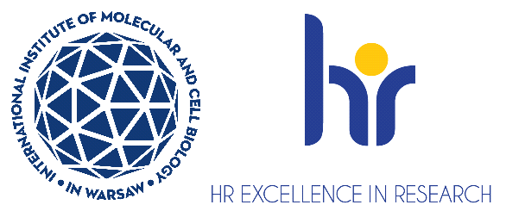

Undergraduate student in the Laboratory of Cell Biology

The Laboratory of Cell Biology miaczynska lab at the International Institute of Molecular and Cell Biology (IIMCB), Warsaw, headed by Prof. Marta Miączyńska is seeking an undergraduate student.

You will join the project entitled “AXL receptor signaling in cancer cell growth and drug resistance”, which is carried out as the OPUS (2020/39/B/NZ3/03429) grant of the Polish National Science Centre.
The aim of the project is to study novel regulators of macropinocytosis, an endocytic pathway upregulated in cancer cells and crucial for their nutrition.

As an undergraduate student you will be involved in: culture of cancer cell lines and their CRISPR-mediated genetic modifications, cell transfection, molecular biology and biochemistry techniques, western-blot, immunocytochemistry and confocal fluorescence microscopy, data analysis and reporting.

Candidates will be selected according to the procedure complying the rules for granting scholarships for young scientists in research projects funded by the National Science Centre (NCN Council Resolution No. 25/2019 dated March 14, 2019 r.) and the procedure complying with the rules of the European Charter for Researchers and the Code of Conduct for the Recruitment of Researchers as a part of HR Excellence in Research Strategy https://bit.ly/3U0dydP

Requirements for the candidate:

- Bachelor-level degree in biology, biochemistry or related field obtained
- The candidate must be formally enlisted in MSc studies in Poland (if needed, the work on this project can become an experimental part of MSc thesis)
- Basic knowledge and interest in cell and molecular biology
- Basic experience in laboratory work; practical experience in cell culture will be an advantage
- Motivation and passion for experimental work
- Willingness to learn and take new challenges, analytical thinking, availability
- Good knowledge of English
- Excellent interpersonal skills
- Research experience abroad will be a plus

We offer:

- Fellowship 1500-2500 PLN net, depending on the declared availability/number of working hours. The minimal length of the fellowship is 6 months.
- Participation in lab meetings and institutional seminars, institutional retreats, scientific training, support from peers, and academic mentoring.
- Opportunity to learn several biochemical, molecular and cell biology techniques, under the guidance of experienced lab supervisors.
- Exposure to cutting-edge research methodology available at the IIMCB.
- Work in international environment.

Deadline for applications is 15th September, 2025. Job starting date is to be negotiated.

How to apply:
- Please submit your cv in English.
- Please include the following statement in your cv: “I hereby agree to the processing
of my personal data, included in the application documents by the International Institute of Molecular and Cell Biology in Warsaw, 4 Księcia Trojdena Street, 02-109 Warsaw, for the purpose of carrying out the current recruitment process.” Your personal data will be processed for the purpose of the recruitment procedure by the International Institute of Molecular and Cell Biology in Warsaw. Full information is available under the link https://bit.ly/3UFWpY2
- Procedure for reporting irregularities, taking follow-up actions, and protecting whistleblowers: https://shorturl.at/u2mww

The competition may be extended until a suitable candidate who fulfills all requirements
is found.

