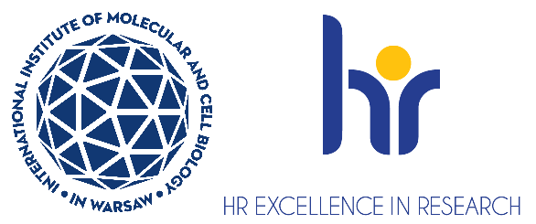

Postdoctoral Researcher in the Laboratory of Protein Structure
Laboratory of Protein Structure ( https://shorturl.at/iZTMe ) at the International Institute of Molecular and Cell Biology (IIMCB), Warsaw, headed by Prof. Marcin Nowotny is looking for two Postdoctoral Researchers to join the project entitled “Mechanistic and structural studies of adenoviral DNA replication”, which is carried out as the OPUS grant (UMO-2024/55/B/NZ1/02607) of the Polish National Science Centre. The project aims at the structural and mechanistic characterization of replication of adenoviruses using structural biology (crystallography and cryo-electron microscopy) and protein biochemistry approaches.
The ideal candidate should be able to pursue challenging tasks and achieve objectives and collaborate with other researchers. Candidates will be selected in an open competition, according to the procedure complying with the rules of the European Charter for Researchers and the Code of Conduct for the Recruitment of Researchers as a part of HR Excellence in Research Strategy https://shorturl.at/f2CpW
The deadline for applications is 31.07.2025. Start of employment is 01.09.2025.
For more information about our laboratory and research, please visit: Laboratory of Protein Structure
As a Postdoctoral Researcher: You will be responsible for biochemical and structural studies of proteins and complexes involved in adenoviral replication.
Candidate profile:
We are looking for a candidate with strong scientific curiosity, problem-solving skills, and the ability to drive research independently while actively engaging with the scientific community. The ideal candidate should demonstrate an eagerness to explore new areas within ubiquitin signaling and be proactive in developing research directions aligned with the project's goals.
Requirements:
- Holds a doctoral degree in biology, biotechnology, or biochemistry. Obtaining a doctoral degree in the year of employment in the project or within 12 years before January 1 of the year of employment in the project
- Fulfills the formal criteria for the competition criteria in particular section 2.1.1
- Has experience in protein biochemistry/purification (particularly for nucleic acid enzymes), crystallography and/or cryo-EM
- Has strong written and oral communication skills in English
- Has good presentation skills (ideally having presented during at least one international conference).
- Enjoys working in a highly collaborative and interdisciplinary environment.
- Has published at least one publication in an international peer-reviewed journal.
What we offer:
- Full-time employment contract, initially for 6 months, with the possibility of extension until the end of the project.
- Competitive salary of approximately 8300 PLN gross/month.
- A dynamic and supportive research environment within an internationally recognized institute.
- Professional development opportunities, including:
- Participation in courses, scientific seminars, and international conferences.
- Funding for postdoctoral training and professional courses.
- Mentorship and assistance in applying for independent research grants (e.g., NCN).

Selection criteria:
Applications will be evaluated based on the following criteria:
- Education and formal qualifications.
- Technical expertise and relevance of experience to the project.
- Scientific achievements (e.g., publications, awards, grants, international collaborations).
- Proficiency in English (written and spoken).
- Soft skills, including:
- Clarity and impact of motivation letter.
- Communication and teamwork abilities.
- Organizational and time-management skills.
- Compatibility with the research group’s goals and vision.
How to apply:
- Apply now via erecruiter system link
- Your application must be submitted in English and should contain a CV, a motivation letter,
a description of your key achievements and contacts to at least two potential referees, including one of your supervisors.
- Please include the following statement in your CV: “I hereby agree to the processing of my personal data, included in the application documents by the International Institute of Molecular and Cell Biology in Warsaw, 4 Księcia Trojdena Street, 02-109 Warsaw, for the purpose of carrying out the current recruitment process.”
Your personal data will be processed for the purpose of the recruitment procedure
by the International Institute of Molecular and Cell Biology in Warsaw. Full information
is available under the link https://bit.ly/3UFWpY2
- Procedure for reporting irregularities, taking follow-up actions, and protecting whistleblowers: https://shorturl.at/u2mww
- The competition may be extended until a suitable candidate who fulfils all requirements
is found.

