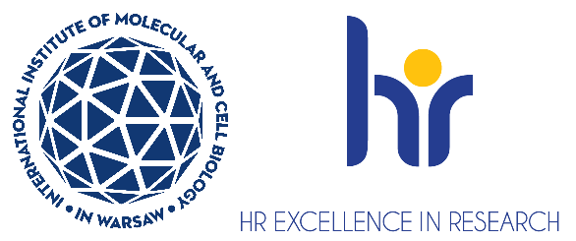

Postdoctoral Researcher Position in the Laboratory of Cellular Genomics
The Laboratory of Cellular Genomics at the International Institute for Molecular and Cell Biology (IIMCB) https://shorturl.at/EEwOl Warsaw, headed by Dr Aleksandra Kołodziejczyk, seeks
a motivated Postdoctoral Researcher to join a project that aims to study molecular mechanisms behind liver fibrosis and the role of the microbiome in the profibrotic processes. You will work on the project funded by OPUS grant of the National Science Centre, Poland entitled: “Finding molecular mechanisms behind the activation of stellate cells” (2023/51/B/NZ2/02649). More information about the lab: olab.com.pl
The deadline for applications is 30th June 2025. The proposed start date of employment is 1st October 2025 (flexible).
As a Postdoctoral researcher, you will be responsible for multi-omic analysis of the fibrotic processes in the host, with a particular focus on the liver stellate cells and the impact of the microbiota.
Requirements:
- Hold a PhD degree in Biology, Biotechnology, Medicine or an equivalent field. Candidates with degrees in other fields including Engineering, Computer science, or Physics will also be considered if they have relevant experience
- Fulfill the formal criteria for the competition https://shorturl.at/cvy5V in particular section 2.1.1
- Excellent written and oral communication skills in English
- High motivation and proactive and collaborative attitude
Previous experience in one or more methods mentioned below:
- analysis of eukaryotic gene expression (RNAseq, spatial transcriptomics)
- analysis of chromatin structure (ATACseq, ChIPseq, HiC, etc.)
- analysis of metagenomics or metaproteomics data
- machine learning for the identification of clinical targets
We offer:
- Full employment contract initially for 6 months, with the possibility of extension up to 36 months
- Salary (8310-8700 pln gross/month)
- A friendly working atmosphere in an international environment
- Interesting scientific projects
- Position with 100% focus on research (no teaching obligations)
- Benefits, including a reduced-rate for an individual medical care package and membership
in MultiSport programme
- Full technical, administrative and organizational support from professional English-speaking personnel
- Opportunities for professional development - participation in courses, foreign conferences, funding for postgraduate studies, assistance in submitting own grants
Selection criteria:

Applications will be evaluated based on the following criteria:
- Education and formal qualifications.
- Technical expertise and relevance of experience to the project.
- Scientific achievements (e.g., publications, awards, grants, international collaborations).
- Proficiency in English (written and spoken).
- Soft skills, including:
  - Clarity and impact of motivation letter.
  - Communication and teamwork abilities.
  - Organizational and time-management skills.
  - Compatibility with the research group’s goals and vision.
How to apply:
- Your application must be submitted in English and should contain:
  - CV (including a list of publications)
  - motivation letter (max one page)
  - contact information (email address or phone number) to two people who can evaluate you (such as your thesis supervisor, or academic advisor)
- Please include the following statement in your CV:
“I hereby agree to the processing of my personal data, included in the application documents by the International Institute of Molecular and Cell Biology in Warsaw, 4 Księcia Trojdena Street, 02-109 Warsaw, for the purpose of carrying out the current recruitment process.”
Your personal data will be processed for the purpose of the recruitment procedure by the International Institute of Molecular and Cell Biology in Warsaw. Full information is available https://bit.ly/3UFWpY2
- Procedure for reporting irregularities, taking follow-up actions, and protecting whistleblowers: https://shorturl.at/u2mww

Candidates will be selected in an open competition, according to the procedure complying with the rules of the European Charter for Researchers and the Code of Conduct for the Recruitment of Researchers as a part of HR Excellence in Research strategy https://shorturl.at/mCSZt
If you have questions about further details, please email akolodziejczyk@iimcb.gov.pl

